SALTER/SAULTER 2019 FAMILY REUNION REGISTRATION FORM

First Name ___________________ Last Name _______________________
Address ________________________________________________________
Contact # ____________________ Email ___________________________
# in Family attending: Meet & Greet ____, Picnic _____, Banquet _____, Sunday Dinner _____
BANQUET FEES:
Adults (age 12 & ↑) _____ X $25.00=_____
Kids age (age 4-11) _____ X $12.50=_____ (kids menu, chicken strips, fries, applesauce)
TOTAL COST / AMT ENCLOSED FOR BANQUET

FAMILY PICNIC
PER HOUSEHOLD COST $10

FAMILY SCHOLARHIP FUND (Donation)

ANNUAL FAMILY DUES $50

T-SHIRTS/POLOS/HATS (see other side for shirt design)
PLEASE INDICATE # OF EACH SIZE
T-shirt Children ($8) ___S ___M ___L ___XL
T-Shirts Adult ($10) ___S ___M ___ L ___XL ($11) ___2X ___3X ___ ___4X
Polo Shirt Adult ($15) S ___M ___L ___XL Hats ($12 ) ___

TOTAL COST / AMT ENCLOSED FOR SHIRTS/HATS

SEE OTHER SIDE FOR TOTAL & MAILING INSTRUCTIONS →
GRAND TOTAL ENCLOSED → → → →

Send all monies and registration form to:  Rose Stamps  99 Nome Way, Unit B  Aurora, CO 80012 | Mail Scholarship Applications (only) to:  Marcia Norman Murray  ATTN: SSFR Scholarship Committee  10325 Scarborough Rd  Bloomington, MN 55437
ALL FEES ARE DUE BY 6/1/2019 – Make checks payable to Salter/Saulter Family Reunion

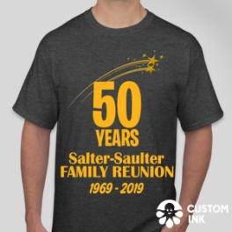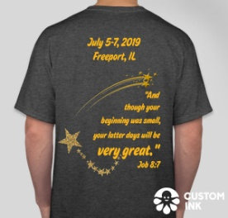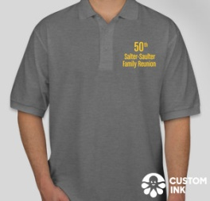
T-Shirt Front T-Shirt Back Polo Hat
Apparel is dark gray with gold lettering

