SSFR Scholarship Fundraiser:
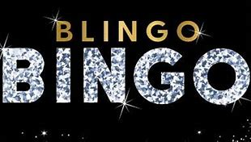

Friday, July 8, 2022 at 9:00pm
McPherson Room

So, you think a normal bingo night is a little too dull? Then be sure to attend our first-ever “Blingo Bingo Night”!

The goal of the “Blingo” bingo game is to raise money for the Salter-Saulter Memorial Scholarship Fund. It may not raise a fortune, but it is a great excuse for family to get together for a fun evening together to support of a great cause.

A prize will be awarded to the King & Queen of “BLING” winners

Everyone should come drenched in glitz & glam, sparkly, or handsomely shined up, with over-the-top bling wear and far too much bling jewelry and accessories!! Gentlemen you’re not excluded. Put on that eye-popping watch, ring, tie pin, necklace, or bracelet you forgot you owned and haven’t worn in long time!

In addition to your participation, we need everyone’s help by donating great prizes for the game winners for each round played. Go ahead and empty out your jewelry box and bring along with you that jewelry not quite your style anymore. Think about a good book you have on hand to share, or a bottle of wine, family memorabilia, scarves, gift cards, or any small items that will fit into your luggage. Be unique and creative — it’s for a good cause!

For questions, please contact:
Brandi Salter: bcsalter1@gmail.com or
Joyce Salter Johnson: Joyceboggess39@gmail.com

